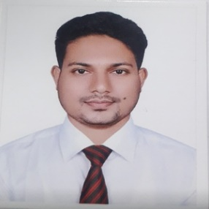**Robiul Islam**

**Mailing Address:**

Shaheed Moktar Elahi Hall

Begum Rokeya University, Rangpur

Mobile No: 01772303346

E-mail: robiulislam303346@gmail.com

**Career Object**:

An academically solid background in social research, human behavior, and cultural studies characterizes this driven and curious sociology student. Willing to use internships or entrylevel positions in social services, community development, or research to put theoretical knowledge to use in solving genuine problems. Devoted to using evidence-based strategies to advance social justice, inclusivity, and constructive social change.

**Academic Qualification:**

|  |  |  |  |  |
| --- | --- | --- | --- | --- |
| **Exam** | **Subject/Group** | **Institute** | **Result** | **Year of Passing** |
| BSS (Honours) | Sociology | Begum Rokeya University, Rangpur | CGPA 3.32 | 2022 |
| H.S.C | Humanities | Mohonpur Degree College, Rajshahi | GPA 4.17  (Out of 5.00) | 2017 |
| S.S.C | Science | Mohobbatpur High School, Rajshahi | GPA 4.67  (Out of 5.00) | 2015 |

|  |  |  |  |
| --- | --- | --- | --- |
| **Language** | **Reading** | **Writing** | **Speaking** |
| Bangla | Excellent | Excellent | Native |
| English | Excellent | Excellent | Excellent |

**Language Proficiency:**

**Key skills:**

* MS Office package (MS-Word, MS-Excel, MS-PowerPoint),Internet browsing
  + - Online classroom management skill
    - Problem solving skill

**Interpersonal Skills:**

* Outstanding communication and interpersonal skills;
* Positivity, self-assurance, and friendliness as a person;
* Decision-making and problem-solving abilities;
* Strong presentation abilities;
* Comfortable in both a relaxed and demanding work environment;   
  strong talent at numbers and analysis.

**Personal Information:**

Name : Robiul Islam

Father’s Name : Dares Ali

Mother’s Name : Shahida Begum

Permanent Address : Village: Mohobbatpur; Post Office: Dhuroil

Upazilla: Mohonpur; District: Rajshahi

|  |  |
| --- | --- |
| Date of Birth | :10/05/1999 |
| NID number | : 6905526403 |
| Cell Number | : 01772303346 |
| Gender | : Male |
| Marital Status | : Married |
| Nationality | : Bangladeshi |

Robiul

**Signature**